SIMATS ENGINEERING

SAVEETHA INSTITUTE OF MEDICAL AND TECHNICAL SCIENCES DEPARTMENT OF COMPUTER SCIENCE AND ENGINEERING
CO1–ASSESSMENT TOOL 1
Analytical Problem Solving
COURSE NAME: Artificial Intelligence COURSE CODE: CSA1715
QUESTIONS: 5 Duration:1Hour Total Marks:50

Criteria | Weightage |  | Q2 (10) | Q3 (10) | Q4 (10) | Q5 (10) | Total Marks  (50)
Problem  Understanding | 20%(2) | /2 | /2 | /2 | /2 | /2 | /10
Method  Selection | 20%(2) | /2 | /2 | /2 | /2 | /2 | /10
Solution  Process | 25%(2.5) | /2.5 | /2.5 | /2.5 | /2.5 | /2.5 | /12.5
Accuracy of  Calculation | 20%(2) | /2 | /2 | /2 | /2 | /2 | /10
Interpretation  of Results | 15%(1.5) | /1.5 | /1.5 | /1.5 | /1.5 | /1.5 | /7.5
Totalper  Question | 10 Marks | /10 | /10 | /10 | /10 | /10 | /50

100

SIMATS ENGINEERING
ASSESSMENTTOOL 1

COURSE NAME: Artificial Intelligence COURSE CODE:CSA1715

COURSEOUTCOMECOVERED

CO1:ApplyAIbasicssuchasintelligentagentsanduninformedsearchmethodstosolve problems effectively. (BL3)

AssessmentToolWeightage:40%

QUESTIONS:5Duration:1Hour
TotalMarks:50
AnnexureA

AnalyticalProblemSolving

CodeofConduct

Iam_VARSHITHAMAHADEVAN(192511147)_(Name/RegNo)certify that this submission is my original work and that I have adhered to the guidelines specified for this assessment.
Iunderstandthatanyviolationofacademicintegrityruleswillresultindisciplinary action.

Signatureof thestudent:Varshitha mahadevan


ANNEXUREA

ANALYTICALPROBLEMSOLVING
Question1:WaterJug Problem

ProblemUnderstanding:
Twojugsareavailable:4-gallonand3-gallon.Theobjectiveistoobtainexactly2gallons in the 4-gallon jug.
InitialState:(0,0) Goal State: (2,x)

Step | Action | State(4G,3G)
1 | Fill3-gallonjug | (0,3)
2 | Pourinto4-gallonjug | (3,0)
3 | Fill3-gallonjugagain | (3,3)
4 | Pourinto4-gallonuntilfull | (4,2)
5 | Empty4-gallon jug | (0,2)
6 | Pourremaining2gallons into 4-gallon jug | (2,0)

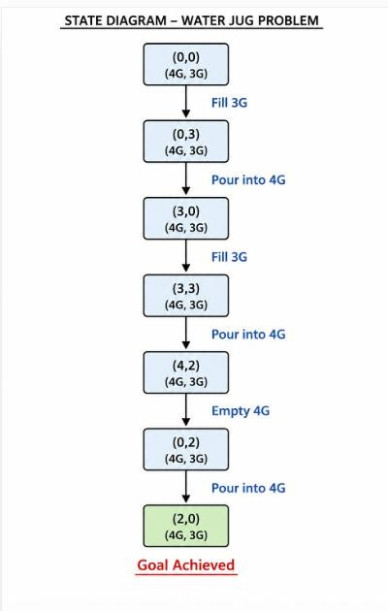

Algorithm:
- Fill3G.
- Pour into 4G.
- Fill3Gagain.
- Pouruntil 4G is full.
- Empty4G.
- Pourremainingwaterinto 4G.

Question2:MarsRoverIntelligentAgent
Aim

To analyze the Mars Rover as an intelligent agent by identifying its percepts, operatingenvironment, actions, performance measures, and suitable agent architecture.
ProblemUnderstanding

The Mars Rover is an autonomous robotic vehicle developed to explore the surface of Mars. It performs scientific experiments, collects rock and soil samples, captures images, avoids obstacles, and transmits valuable information back to Earth without continuous human control.


PEASDescription

PEAS  Component | Description
Performance Measure | Collectmaximumsamples,avoidobstacles,conservebattery, transmit accurate data, complete mission successfully
Environment | Marssurface,rocks,hills,craters,duststorms,varyingtemperatures, sunlight
Actuators | Wheels,roboticarm,drill,camerarotation,antenna,samplecollector
Sensors (Percepts) | Cameras,temperaturesensor,proximitysensor,radiationsensor, battery sensor, gyroscope, spectrometer


(i) Percepts

TheMarsRover continuouslyreceivesinformation fromits sensors.

• Images from cameras
• Rock and soil samples
• Temperature
• Atmospheric pressure
• Terrain information
• Obstacle detection
• Position (GPS/Navigation sensors)
(ii)OperatingEnvironment

• Partially observable
• Dynamic
• Sequential
• Continuous
• Single-agent

(iii)ActionsPerformedbytheRover

TheMars Rover can:
• Move forward/backward
• Turn left/right
• Collect rock samples
• Drill rocks
• Capture images
• Analyze soil
• Send data to Earth
• Avoid obstacles

(iv)PerformanceEvaluation

Therover's performance is evaluated usingthe following criteria:

• Number of samples collected
• Accuracy of analysis
• Distance covered
• Energy efficiency
• Mission completion
• Safe navigation
(v)SuitableAgentArchitecture
Model-Based Goal-Based Agent
Reason:
- Maintains an internal model of Mars.
- Plans routes to achieve goals.
- Avoids obstacles.
- Makes intelligent decisions even when the environment changes.
AgentArchitectureDiagram

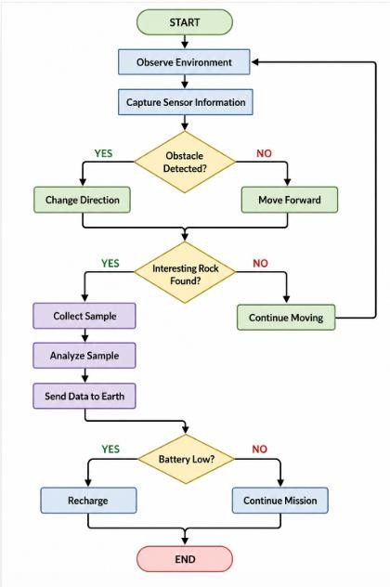
WorkingFlowchart


Conclusion
The Mars Rover is an intelligent autonomous system that operates in a partially observable, dynamic, stochastic, and continuous environment. A Utility-Based Learning Agent is the most suitable architecture because it enables the rover to learn from experience, optimize its decisions, conserve energy, and maximize the success of scientific exploration on Mars. This approach improves mission efficiency and ensures reliable autonomous operation in the challenging Martian environment.

Question3:8-QueensProblem
Aim

Toformulatethe8-QueensProblemasasearchproblemandsolveitusingthe Backtracking Search Algorithm (Depth First Search).

ProblemStatement

The8-QueensProblem isoneofthemostpopularproblemsinArtificialIntelligence.

Theobjectiveistoplace8queensonan8×8chessboardsothatnoqueenattacks another queen.

Aqueenattacksanotherqueen ifbotharein:

- Thesame row
- Thesame column
- Thesame diagonal

Thechallengeisto findanarrangement wherealleight queensareplaced safely.


ProblemFormulation
Initial State

An empty8×8chessboard.

0 Queens placed

STATE SPACE

All possible arrangements of 8 queens on the chessboard.

ACTIONS
Place one queen in a safe position in the next column.

GOAL STATE
No two queens should attack each other:
- Same row ❌
- Same column ❌
- Same diagonal ❌

PATH COST
Each queen placement has a cost of 1.
The solution is reached after placing all 8 queens safely.

Search Strategy
- Backtracking Search
- Depth-First Search (DFS)


Working Steps
- Startwith Column1 andplacethefirstqueen ina saferow.
- Moveto thenext columnand check each rowfor asafe position.
- Placethequeen iftheselectedpositionissafe(no rowordiagonalconflict).
- Repeattheprocessfor eachremainingcolumnuntilallqueensare placed.
- Ifaconflictoccurs,removethepreviouslyplacedqueen(Backtracking)andtry the next available row.
- Continuebacktrackingwhenever necessaryuntilavalidarrangementis found.
- Stopwhenall8queens areplaced safelywithout attackingeach other.

FinalChessboardSolution

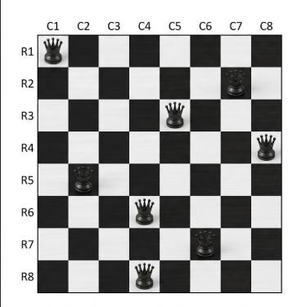

Flowchart

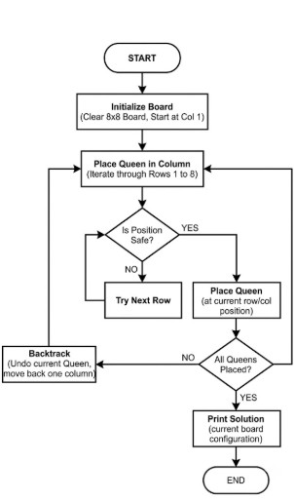


Algorithm

- Startwith thefirst column.
- Placeaqueen ina saferow.
- Moveto thenextcolumn.
- Checkif theposition is safe.
- Ifsafe,placethequeen.
- Ifunsafe, tryanother row.
- Ifnorowissafe,backtracktothepreviouscolumn.
- Repeatuntilallqueensare placed.


Applications

- Artificial Intelligence
- ConstraintSatisfactionProblems(CSP)
- Puzzle Solving
- SchedulingSystems
- ResourceAllocation
- Robot Navigation


Advantages

- Easyto understand.
- Reduces unnecessarysearches.
- Guaranteesavalidsolution.
- Efficientforconstraint-basedproblems.


Conclusion

The 8-Queens Problem is a classic Constraint Satisfaction Problem in Artificial Intelligence. It is efficiently solved using the Backtracking Search Algorithm, which places queens one by one and removes them whenever a conflict occurs. This method ensures that all eight queens are placed safely without attacking each other and demonstrates the effectiveness of Depth First Search (DFS) in solving AI search problems.

Question4:OLACabBookingSystemasaGoal-Based Agent
Aim

TodesignanOLACabBookingSystemasaGoal-BasedIntelligentAgentandexplain its working with algorithm and pseudocode.

ProblemStatement

AnOLACabBookingSystemisanintelligentapplicationthathelpsusersbooktaxisto travel from one location to another.

ThesystemactsasaGoal-BasedAgent,whereitsgoalistofindthemostsuitablecabfor the customer based on the pickup location, destination, driver availability, distance, and estimated fare.


Goal-BasedAgent

AGoal-BasedAgent choosesactionsthathelpachieveaspecific goal.

- Findthenearestavailablecab.
- Bookthecabsuccessfully.
- Reachthedestination safely.
- Completepayment andtrip.


ComponentsoftheOLACabBookingAgent
Percepts(Inputs)

- Userpickup location
- Destination
- GPSlocation

- Availabledrivers
- Trafficconditions
- Estimatedfare
- Customerbooking request

Actions

- Searchnearbycabs
- Calculatefare
- Assignnearest driver
- Sendbooking confirmation
- Tracklive location
- Completepayment
- Endthe trip
Environment

Theagentoperatesin:

- Roadnetwork
- GPSsystem
- Customermobileapp
- Drivermobileapp
- Trafficconditions
- Payment gateway
PerformanceMeasures

Theagentshould:

- Minimizewaitingtime

- Findtheshortestroute
- Reducetraveltime
- Provideaccuratefare
- Ensurecustomersatisfaction


Working Steps

- Thecustomeropensthe OLA application.
- Theuserenters thepickup anddestination locations.
- Thesystemchecksfornearbyavailabledrivers.
- Thenearestsuitabledriveris selected.
- Theestimatedfareandarrivaltimeare displayed.
- Thebooking request issent to the driver.
- Afterdriveracceptance,tripdetailsare confirmed.
- Thecustomertracks the cab inreal time.
- Thedriver reachesthedestination.
- Paymentiscompleted andthetripends.

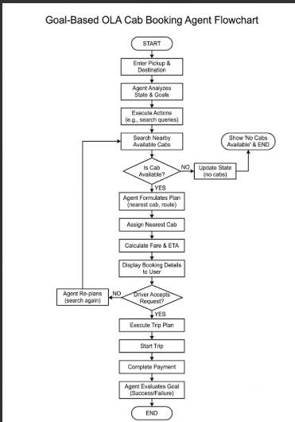


Algorithm

- Startthebooking process.
- Acceptthepickupanddestination locations.
- Search for nearbyavailable drivers.
- Ifnodriverisavailable, displayamessageand stop.
- Assignthenearestavailabledriver.
- Calculatetheestimatedfareandtraveltime.
- Sendthe bookingrequestto thedriver.
- Ifthedriveraccepts,start thetrip.
- Trackthe rideuntil thedestinationis reached.
- Completepaymentandendthe trip.


Advantages

- Reducescustomerwaitingtime.
- Findsthenearestavailable driver.
- Providesreal-time tracking.
- Calculatesfare automatically.
- Improvescustomer convenience.
- Supportssecureonline payment.


Applications

- OLA
- Uber
- Rapido
- Taxi bookingservices
- Ride-sharingplatforms


Conclusion

TheOLACab BookingSystemisanexampleofaGoal-Based IntelligentAgent because itselectsactionsbasedonthegoalofsuccessfullybookingacabandcompletingthetrip. It continuously evaluates driver availability, traffic conditions, and route information to provide efficient and reliable transportation. This approach improves customer satisfaction by reducing waiting time, optimizing routes, and ensuring safe and convenient travel.

Question5:UniformCostSearch(UCS)–LogisticsDeliveryNetwork
Aim

Todeterminetheleast-costpathfromWarehouseS(Source)toWarehouseG(Goal) using the Uniform Cost Search (UCS) algorithm.

ProblemStatement

A logistics company transports packages between warehouses. Each road has a travel cost(fuel+time).Theobjectiveistofindtheminimum-costpathfromStoGusingthe Uniform Cost Search (UCS) algorithm.


GivenWeightedGraph

Edgesand Costs:

Edge | Cost
S → A | 1
S → G | 12
A→ B | 3
A→ C | 1
B→ D | 3
C → D | 1
C → G | 2

Edge | Cost
D→ G | 3

UniformCostSearch(UCS)

UniformCostSearchexpandsthenodewiththelowestcumulativepathcostfirst.It guarantees the optimal solution when all edge costs are positive.


UCSWorkingSteps
Step1

Start at S. Frontier:(S,0)

Step2

Expand S. Possiblepaths:
- S → A=1
- S → G=12

ChooseA(lowest cost).


Step3

Expand A. Possiblepaths:
- S → A→ B=4
- S → A→ C = 2

ChooseC(lowest cost).

Step4

Expand C. Possiblepaths:
- S → A→ C → D=3
- S → A→ C → G=4

ChooseD(cost= 3).

Step5

ExpandD. New path:
- S → A→ C → D→ G=6

Thefrontiernow contains:

- G =4
- B=4
- G =6
- G =12

ChooseG(cost=4). Goal reached.

UCSExpansion Table

Step | ExpandedNode | PathCost
1 | S | 0
2 | A | 1
3 | C | 2
4 | D | 3
5 | G | 4


Least-CostPath
S→A→C→G
TotalCost
1+1+2=4


Algorithm

- Startfromthesourcenode S.
- InsertS intothe priorityqueuewithcost0.
- Removethe nodewith thelowest cumulativecost.
- Expandtheselectednode andcalculatethecostofits neighbors.
- Insertunexploredneighbors intothepriorityqueue.
- Repeatuntilthe goalnode Gisremoved fromthequeue.
- Returnthe pathwith the minimum total cost.


Advantages

- Findstheoptimal(minimum-cost) path.
- Suitableforweightedgraphs.
- Alwaysexpands theleast-cost node first.
- Guaranteesthe shortestpath whenedgecostsarenon-negative.


Applications

- GPSnavigationsystems
- Logisticsanddeliveryrouting
- Robot path planning
- Networkrouting
- Supplychain optimization


Conclusion

TheUniformCostSearch(UCS)algorithmsuccessfullyfindstheminimum-costpath from S to G.
Final Answer

- OptimalPath:S→A→C→ G
- MinimumCost:4

Thisisthe least-costroute fortransportingthe packagethrough thewarehousenetwork.

